**Deployment Manual**

**Project title:Employee Management System**

**Team members:**

1. ***Akanksha Kumari***
2. ***V.Dhesinguraja***
3. ***D.Kavitha***
4. ***Ch.Pawan kumar***

**Github Details:**

**GithubLink:https://github.com/akankshabarh01/Employee_Management_System.git**

**Passwords used for Employee Management System application:**

1. **DB Credentials: Usernsme--SYSTEM Password—kavitha**
2. **Application Default Login Credentials:User Name:--Raja Password---AK**

**Port Numbers used for Employee Management System application:**

1. **Tomcat Port Number used for Spring Boot application in this project:** 9091
2. **Angular Port Number used for Angular application in this project: 4200**

**Steps to add project in eclipse work Space using git bash:**

1. ***Download git hub***
2. ***Create folder in work space***
3. ***Open git bash***
4. ***Copy work space folder path and past the git bash***

* ***$ cd C:/Employee_Management_System_Workspace***

1. ***Go to git hub ---code--copy the link then enter git bash in git clone and copy the link***

* ***$ git clone https://github.com/akankshabarh01/Employee_Management_System.git***

1. ***enter cd in git bash press tab button***

* ***$ cd***

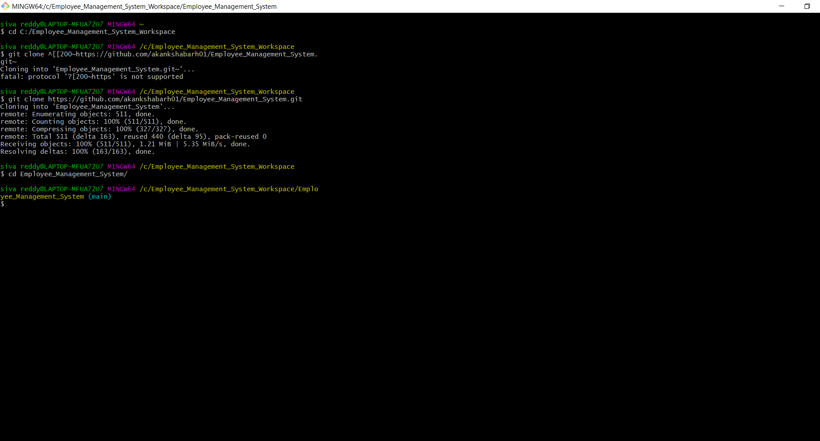

1. ***go to eclipse choose file--switch work Space-->others-->browse-->select folder path--> launch***
2. ***Open* project o*n eclipse go to project file***
3. ***Then right click on project Name***
4. ***Go run and choose maven clean***
5. ***Go to do refresh***
6. ***Go to maven build and give goal-->clean install and click apply then run***

***Maven Clean:***

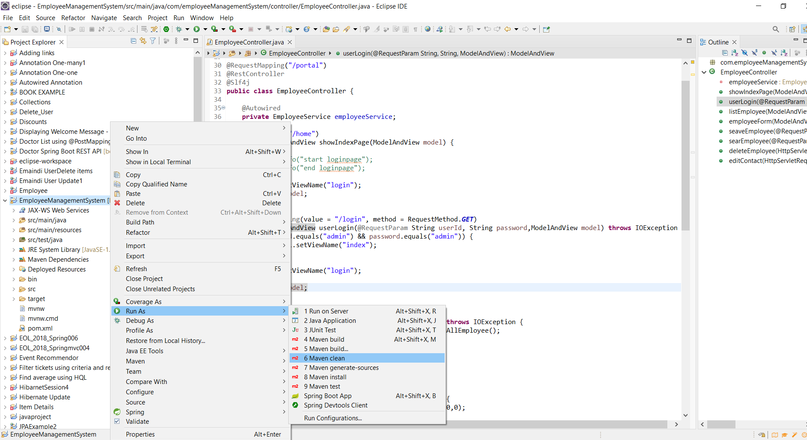

**Maven Clean Success:**

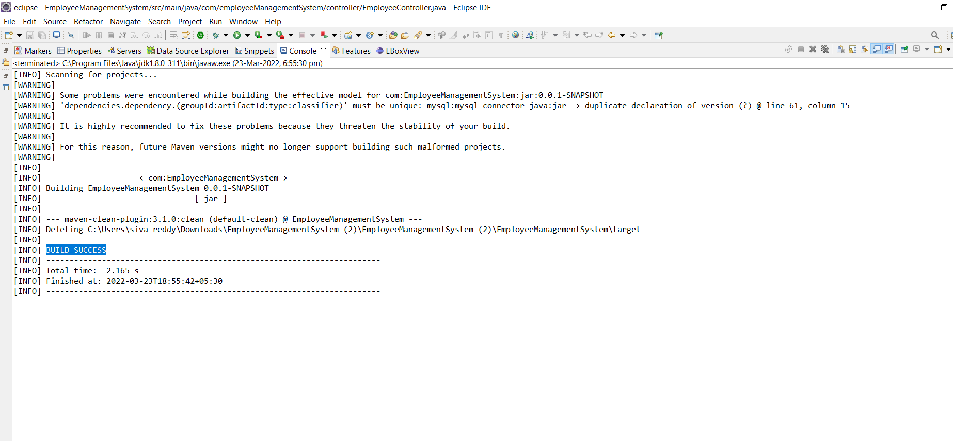

**Refresh:**

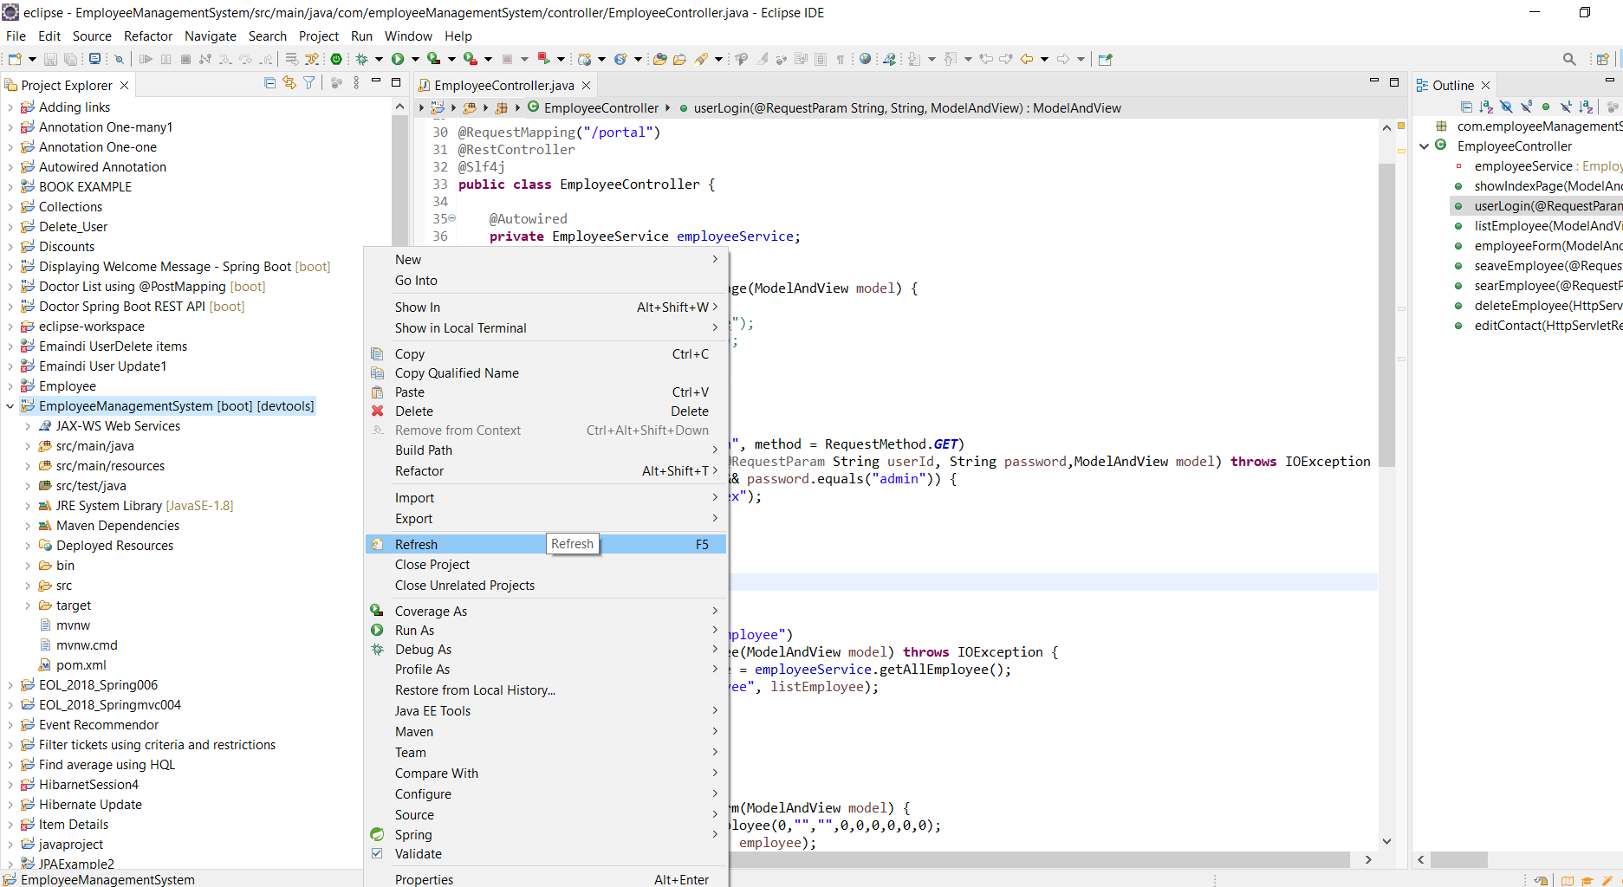

**Maven Build:**

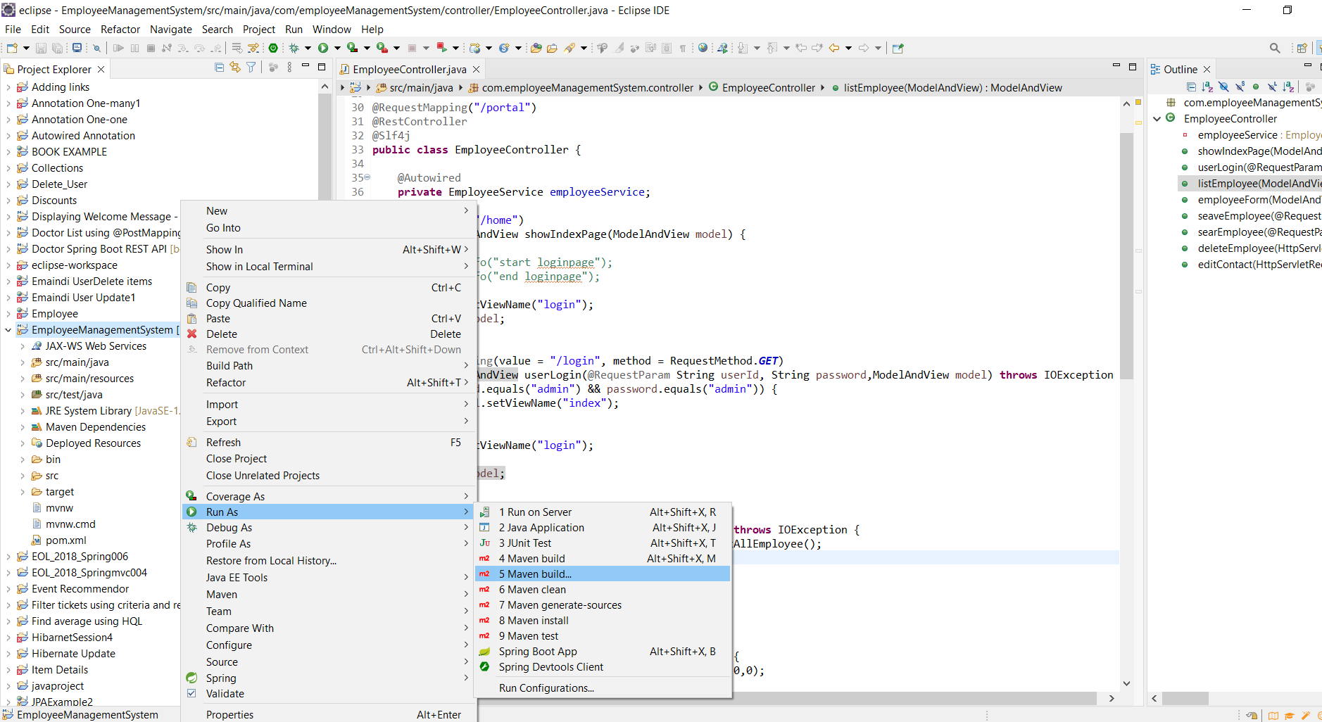

**Given Goal and apply then run:**

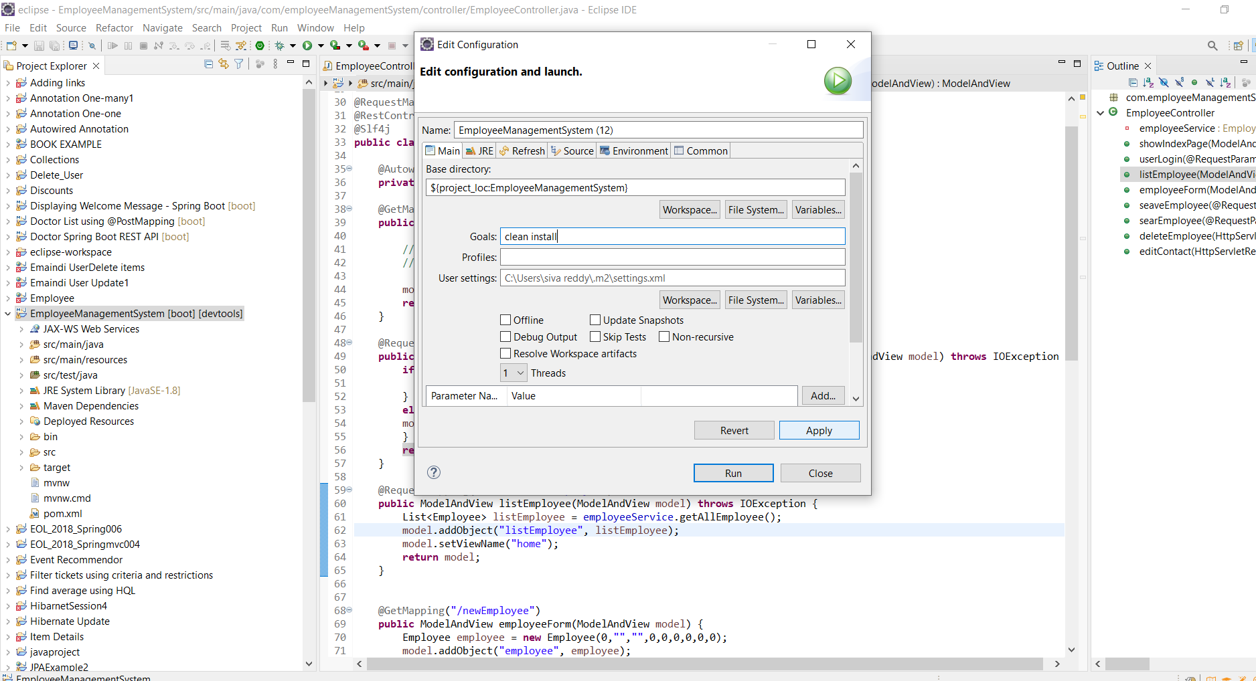

**Maven Build sucess:**

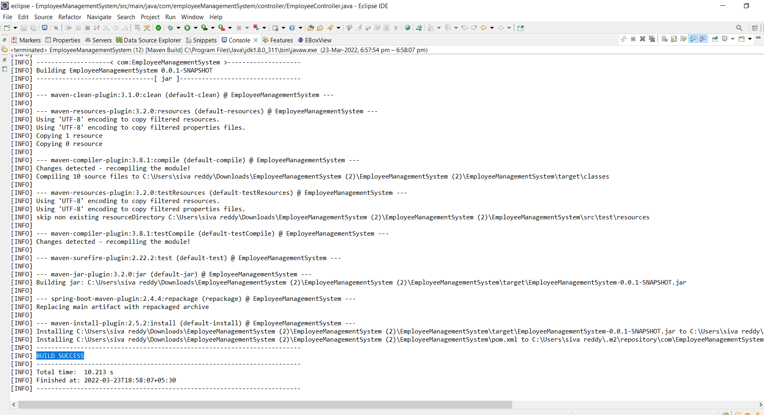

**Create Data Base Table:**

1. ***we have to download oracle 11g and sql developer***
2. ***We can create tables Employee, User***

***GitHub project link for the Database script:***

***https://github.com/akankshabarh01/Employee_Management_System/tree/main/Database%20Script***

***Create tables:***

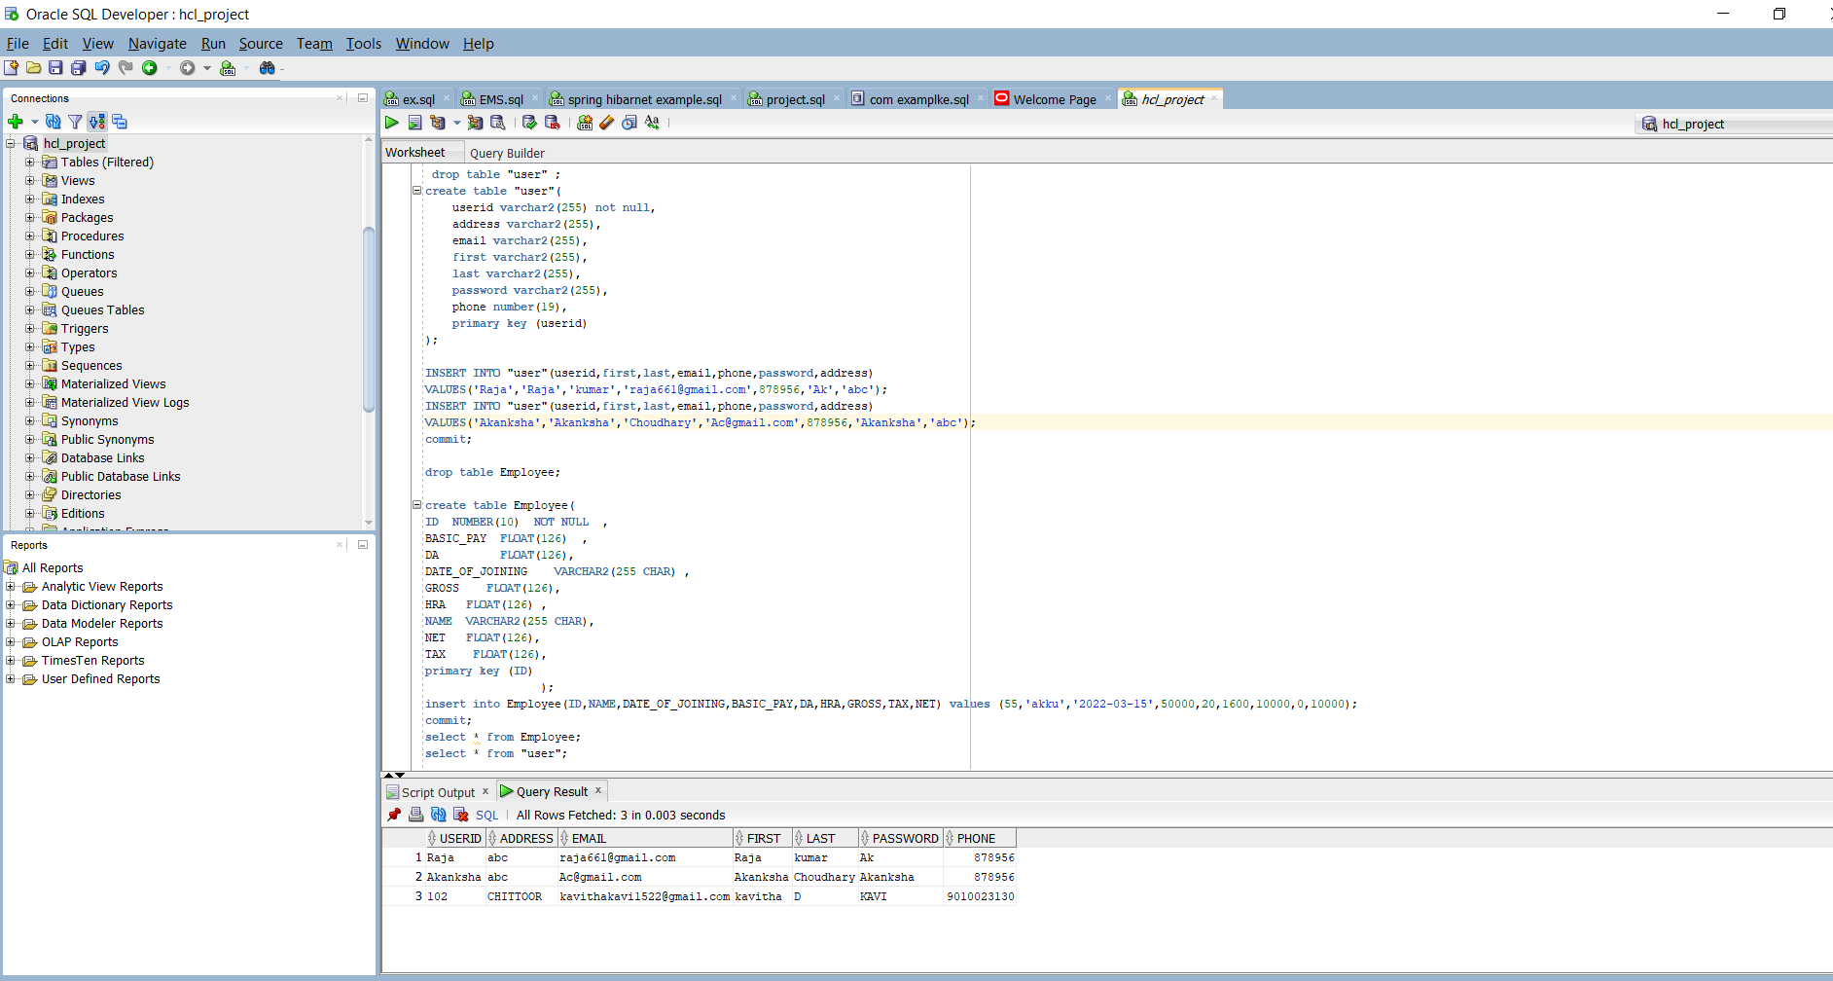

**Steps to import and Run Angular Js Code In Cmd:**

1. ***First we download***
2. ***. Download and install Node.js (including NPM) in windows system for 64 bit***

* ***https://nodejs.org/en/download/***

1. ***Go to command prompt***
2. ***Command to check the Node.js version installed in system: node -v***
3. ***Command to Install the Angular CLI: npm install -g @angular/cli***
4. ***Command to check Angular and NPM Software versions installed in your system: ng --version***
5. ***Go to GitHub clone Folder to Webapp/view/***
6. ***Change directory to your application using :cd employeeApplication***
7. ***Command to Compile and Run the Angular App: ng serve***
8. ***Open browser and access the Application using the below URL:*** [*http://localhost:4200/*](http://localhost:4200/)

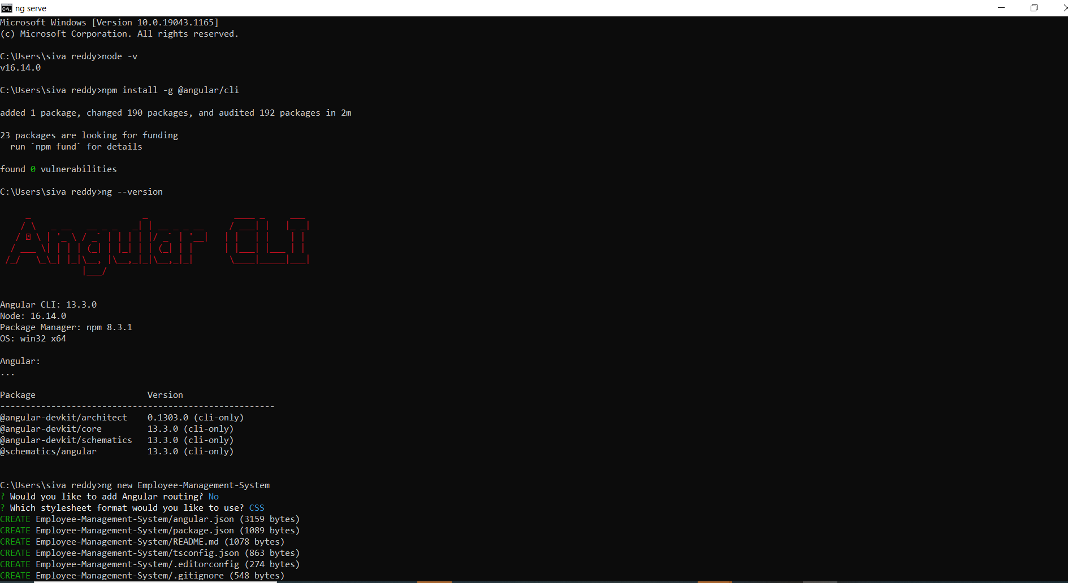

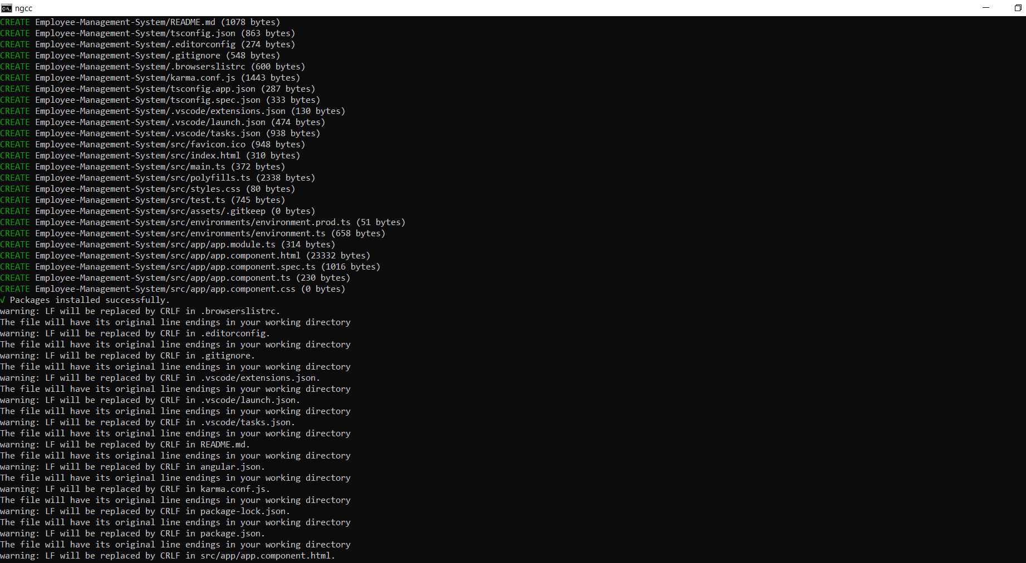

***Project Testing / Access:***

1. ***Open url :*** [*http://localhost:4200/*](http://localhost:4200/) ***from browser***
2. ***To login into the application use Default Login User id – ‘Raja‘and Default Login Password – ‘AK’.***
3. ***Once you successfully log into the application, you can use the below application functionalities:***
4. ***View All Employee Details***
5. ***Edit Employee by Employee ID***
6. ***Add Employee Details***
7. ***Create New Employee***
8. ***Delete Employee by Employee ID***

